AIM:

PART A
(Part A: TO BE REFERRED BY STUDENTS)

Experiment No. 05

Apply DML select statement with where clause, and, or, not, in, between and like clauses.

Pre requisite:
Fundamental knowledge of DML instructions and the SQL.

Outcome:
After successful completion of this experiment students will be able to
    - Design the relational model with basic constrains.
    - Apply the DML commands on the developed relational models.
    - Differentiate between various clauses used with DML commands.

Theory:
The select statement is used to view records from the database. In order to view only specific records, select statement is used with where clause. The SQL WHERE clause is used to specify a condition while fetching the data from single table or joining with multiple tables. If the given condition is satisfied, then only it returns specific value from the table. You would use WHERE clause to filter the records and fetching only necessary records.

The WHERE clause is not only used in SELECT statement, but it is also used in UPDATE, DELETE statement, etc.,

SQL syntax for Select statement with where clause:
SELECT column_name,column_name
FROM table_name
WHERE column_name operator value;

select * from customers where country=’CHINA’;

The above query will select customers from the country CHINA.

The SQL requires single quotes around text values (as shown in above example). However numeric fields should not be enclosed in quotes.

Example:
select * from customers where customer_id=1;
The following operators can be used in the WHERE clause:

Operator | Description
= | Equal
<> | Not equal
> | Greater than
< | Less than
>= | Greater than or equal
<= | Less than or equal
Between | Between an inclusive range
Like | Search for a pattern
IN | To specify multiple possible values for a column
AND | To combine two conditions – both condition needs to be true
OR | To combine two conditions- either of the two condition has to be  true

Using > operator with where clause:

select employee_id, name from employee where salary>50000;

Using = operator with where clause:
select employee_id, name,salary from employee where name = ‘Hardik’; The IN operator allows you to specify multiple values in a WHERE clause.

SQL IN syntax:

SELECT column_name(s)
FROM table_name
WHERE column_name IN (value1,value2,...);

Example:

The following SQL statement selects all customers with a City of "Paris" or "London": select * from customers where city in (‘Paris’,’London’);

SQL Between operator:

The BETWEEN operator is used to select values within a range. The values can be number, text or dates.

SQL BETWEEN syntax:

SELECT column_name(s)
FROM table_name
WHERE column_name BETWEEN value1 AND value2;

Example:

The following SQL statement selects all products with a price BETWEEN 10 and 20: select * from products where price between 10 and 20;

To display the products outside the range of the previous example, use NOT BETWEEN: select * from products where price not between 10 and 20;

SQL LIKE operator:

The LIKE operator is used in a WHERE clause to search for a specified pattern in a column.

SQL LIKE syntax:
SELECT column_name(s)
FROM table_name
WHERE column_name LIKE pattern;

SQL Wildcard characters:

In SQL, wildcard characters are used with the SQL LIKE operator. SQL wildcards are used to search for data within a table.

With SQL, the wildcards are:

Wildcard | Description
% | A substitute for zero or more characters
_ | A substitute for a single character
[charlist] | Sets and ranges of characters to match
[^charlist] or [!charlist] | Matches only a character NOT specified within the brackets
Using LIKE with SQL Wildcard characters:
The following SQL statement selects all customers with a City starting with "ber": select * from customers where city like ‘ber%’;
The following SQL statement selects all customers with a City containing the pattern "es":

select * from customers where city like ‘%es%’;

The following SQL statement selects all customers with a City starting with any character, followed by "erlin":

select * from customers where city like ‘_erlin’;

The following SQL statement selects all customers with a City starting with "L", followed by any character, followed by "n", followed by any character, followed by "on":

select * from customers where city like ‘L_n_on’;

The following SQL statement selects all customers with a City starting with "b", "s", or "p": select * from customers where city like ‘[bsp]%’;

Task: For given tables solve below queries:
category_header
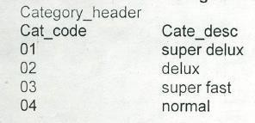

route_Header
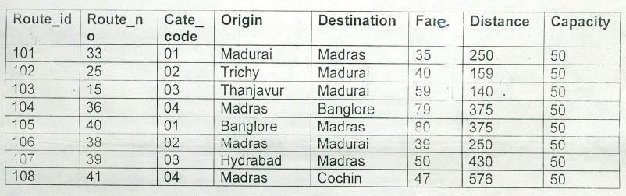

Place Header:
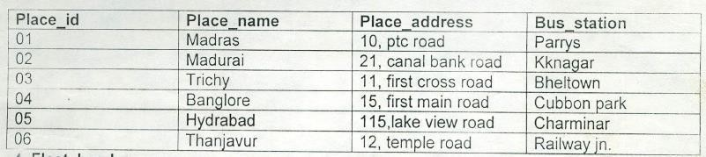

Fleet Header:

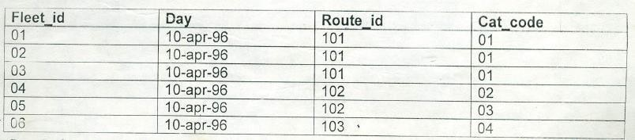

Ticket Header:
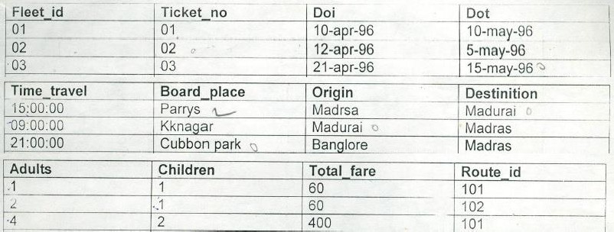

Ticket Detail:

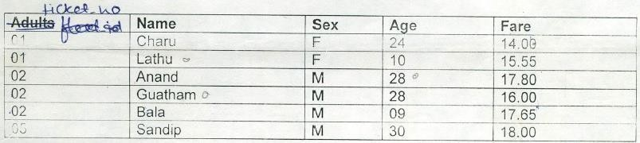

Route Detail:
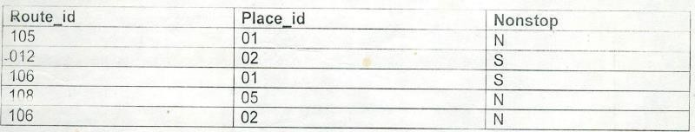

A.5 Tasks to be completed:
Write DML Queries for completing the tasks given below
- Display only those routes that originate in “madras” and terminate in “cochin”.
- Display only those rows from route_header whose origin begins with ‘m’.
- Display only those rows whose fare ranges between 30 and 50.
- Display the fare and the origin for route_no which are greater than 15.
- Display all details of places whose name begins with ‘m’.
- Display those routes whose distance is in range of 200 and 400.
- Find out fleets which travel through route 102 or 103.
- Find out routes which are non stop.
- Find out category whose category description starts with ‘s’ and ends with ‘t’.
- Find out routes which have category code 1, 2 or 4.
- Display details of place with bus station “charminar”.

- Display details of those routes whose fare is less than 70 and distance greater than 120.
- Find out details of tickets issued to female travelers and with age greater than 10.
- What will be fare of each route after incrementing fare by 10 percent?
- Find out details of routes with 101 or 105 or 107.
- Display those routes for which origin is “Madras” and distance is greater than 300 or destination is “Madras” and distance less than 300.
- Create a new table temp_MPSTME with columns as place_id, place_name and place_address (column data type and size must be same as columns of place_header table).
- Write a query to insert records into temp_MPSTME table from place_header table. Only those records are to be selected for which place_id is between 1 to 4 and place_name starts from ‘m’.

PART B
(PART B: TO BE COMPLETED BY STUDENTS)
(Students must submit the soft copy as per following segments within two hours of the practical. The soft copy must be uploaded on the Blackboard or emailed to the concerned lab in charge faculties at the end of the practical in case the there is no Black board access available)

Roll No. : C172 | Name: Parva Gaglani
Class : D | Batch : D2
Date of Experiment : 17/03/26 | Date/Time of Submission : 17/03/26
Grade :

  - Tasks given in PART A to be completed here
(Paste your answers and output here)
    - : Execution of each SQL query used to complete the task given in PART A with results:
TABLE CREATION CODES:
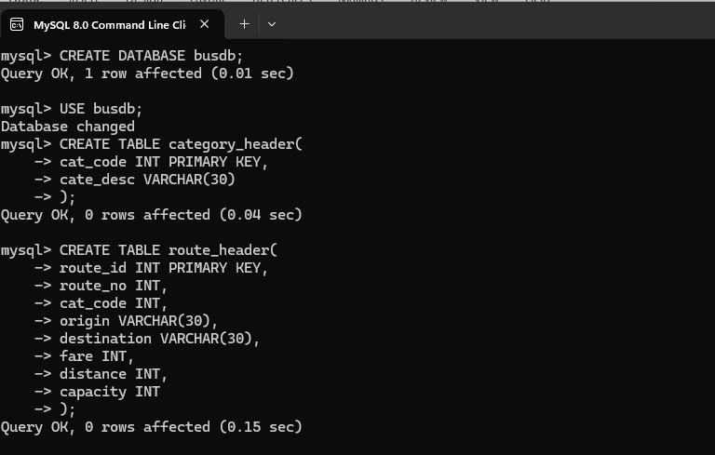

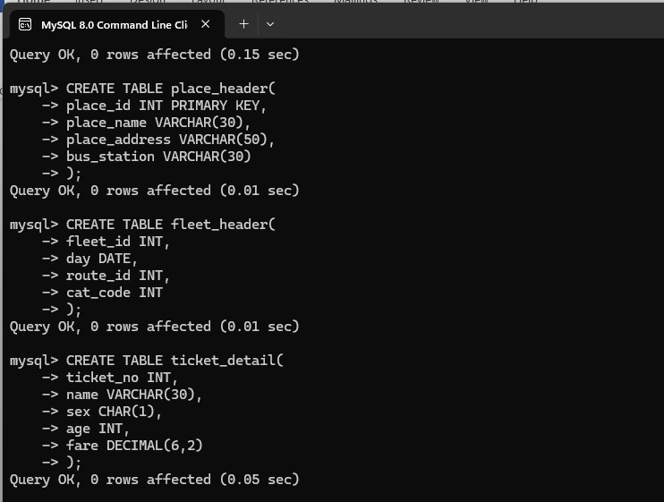

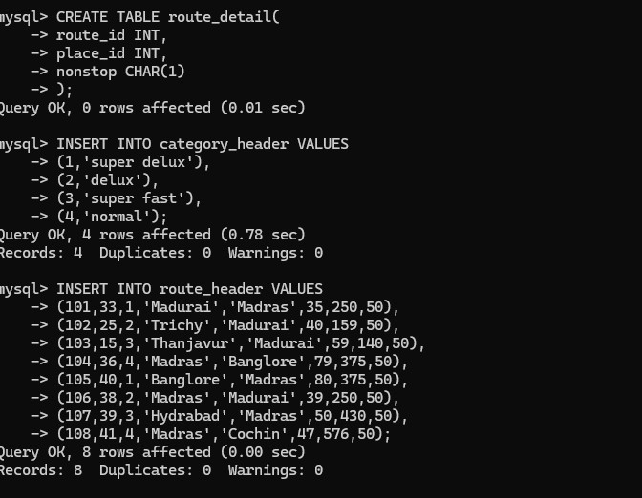

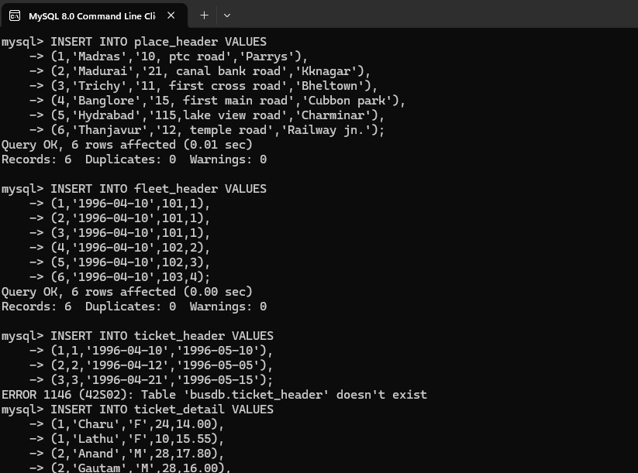
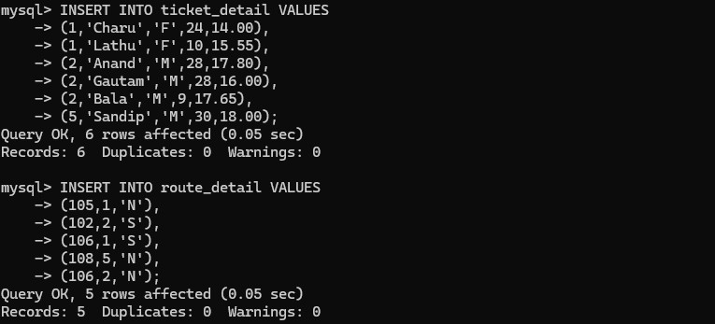

QUERIES:
- Display only those routes that originate in “madras” and terminate in “cochin”.
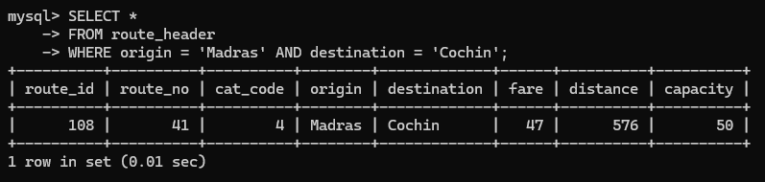

- Display only those rows from route_header whose origin begins with ‘m’.
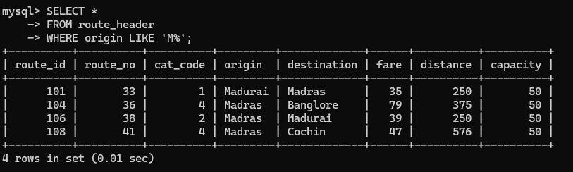

- Display only those rows whose fare ranges between 30 and 50.
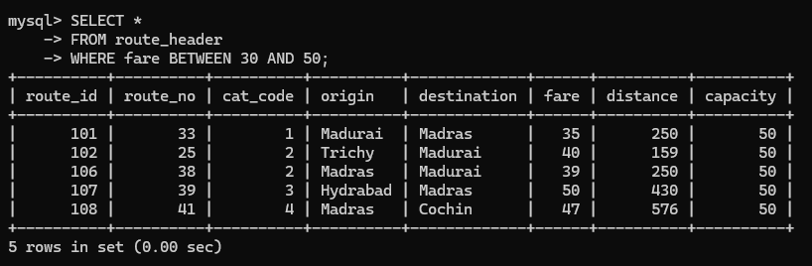

- Display the fare and the origin for route_no which are greater than 15.
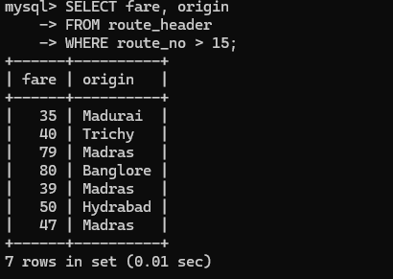

- Display all details of places whose name begins with ‘m’.
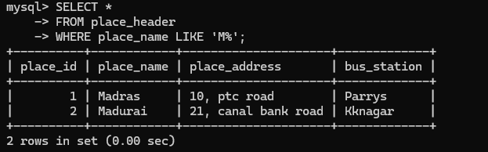

- Display those routes whose distance is in range of 200 and 400.
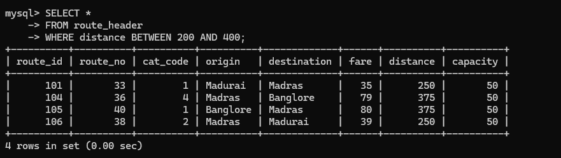

- Find out fleets which travel through route 102 or 103.
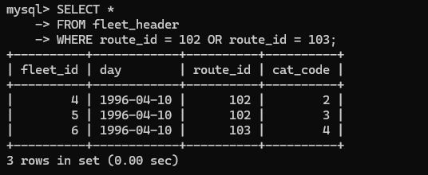

- Find out routes which are non stop.
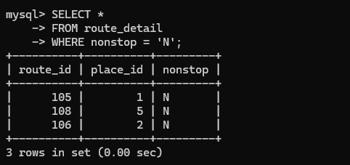

- Find out category whose category description starts with ‘s’ and ends with ‘t’.
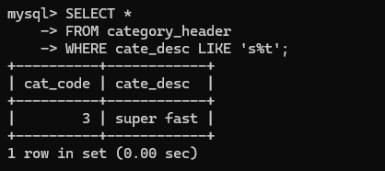

- Find out routes which have category code 1, 2 or 4.
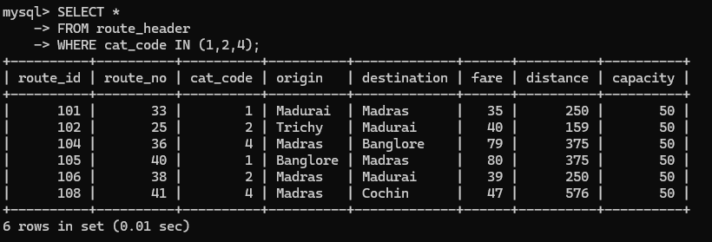
- Display details of place with bus station “charminar”.
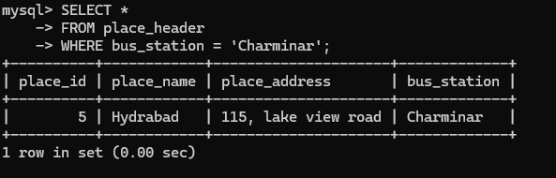

- Display details of those routes whose fare is less than 70 and distance greater than 120.
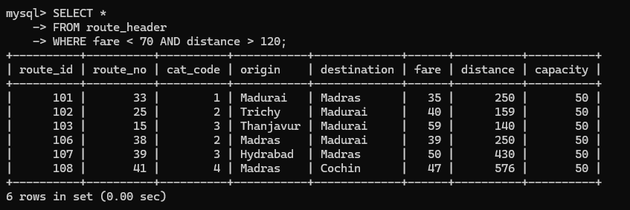

- Find out details of tickets issued to female travelers and with age greater than 10.
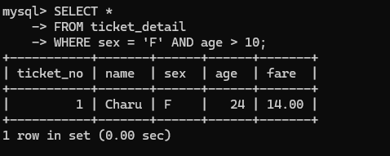

- What will be fare of each route after incrementing fare by 10 percent?
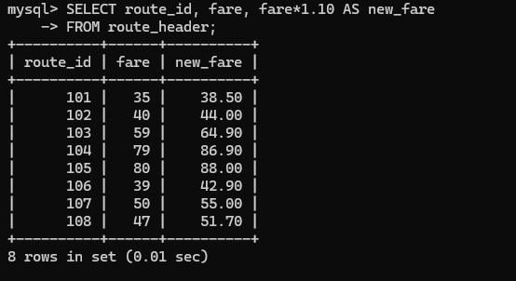

- Find out details of routes with 101 or 105 or 107.
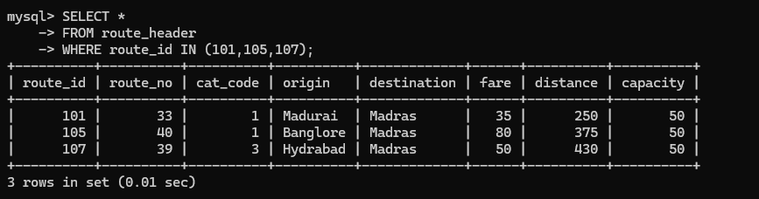
- Display those routes for which origin is “Madras” and distance is greater than 300 or destination is “Madras” and distance less than 300.

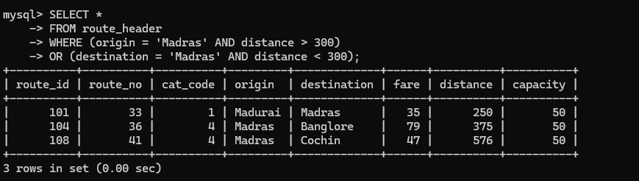

- Create a new table temp_MPSTME with columns as place_id, place_name and place_address (column data type and size must be same as columns of place_header table).

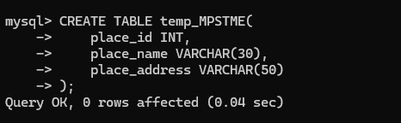

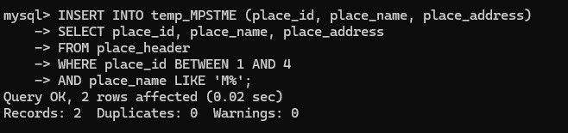
- Write a query to insert records into temp_MPSTME table from place_header table. Only those records are to be selected for which place_id is between 1 to 4 and place_name starts from ‘m’.

B.3 Observations and Learning:

(Students must write the observations and learning based on their understanding built about the subject matter and inferences drawn)
Apply DML select statement with where clause, and, or, not, in, between and like clauses.

B.3 Conclusion:
(Students must write the observations and learning based on their understanding built about the subject matter and inferences drawn)
I created tables again and inserted the appropriate values into each of the tables and also solved DML Queries where we had to update records in each of the tables with the help of SELECT command.
B.4 Question of Curiosity
(To be answered by student based on the practical performed and learning/observations)
- Justify the statement: “Various clauses used with DML helps for better manipulation of the given table.”
Data Manipulation Language (DML) commands such as SELECT, INSERT, UPDATE, and DELETE are used to retrieve and modify data in a database. Various clauses like WHERE, ORDER BY, GROUP BY, HAVING, and LIMIT help in refining these operations. For example, the WHERE clause allows us to filter specific rows based on conditions, while ORDER BY helps arrange the data in ascending or descending order. GROUP BY is used to group similar records together, and HAVING is used to apply conditions on grouped data. These clauses provide flexibility and precision when handling data, allowing users to manipulate only the required records instead of the entire table. Hence, the use of different clauses with DML statements makes database operations more efficient and accurate.

- Differentiate between IN and BETWEEN operators used in databases.
IN Operator | BETWEEN Operator
The IN operator is used to specify multiple possible values in a WHERE clause. | The BETWEEN operator is used to select values within a specified range.
It checks if a value matches any value in a given list. | It checks if a value lies between two given limits.
Example: SELECT * FROM route_header WHERE cat_code IN (1,2,4); | Example: SELECT * FROM route_header WHERE fare BETWEEN 30 AND 50;
Used when values are discrete and specific. | Used when values are continuous ranges.

- What is a wildcard character used in databases?
A wildcard character is a special symbol used in SQL with the LIKE operator to search for patterns in text data. Wildcards help retrieve records when the exact value is not known. The most commonly used wildcard characters are % and _. The % (percent) symbol represents any number of characters, while the _ (underscore) represents exactly one character. For example, the query SELECT * FROM place_header WHERE place_name LIKE 'M%'; will display all places whose names start with the letter M. Wildcard characters are very useful for flexible and partial matching of data in database queries.

